**Implementing NoSQL Database in Firebase**

**For Tailor App**

**_____________________**

**403L-Database Management Systems**

**Department of Computer System Engineering**

**University of Engineering and Technology Peshawar**

Submitted to: **Engr. Sumayyea Salahuddin**

Submitted by:

**Muhammad Umar Jan- 21PWCSE2000**

**Muhammad Saad - 21PWCSE1997**

**Hamza- 21PWCSE1990**



**Implementing NoSQL Database in Firebase**

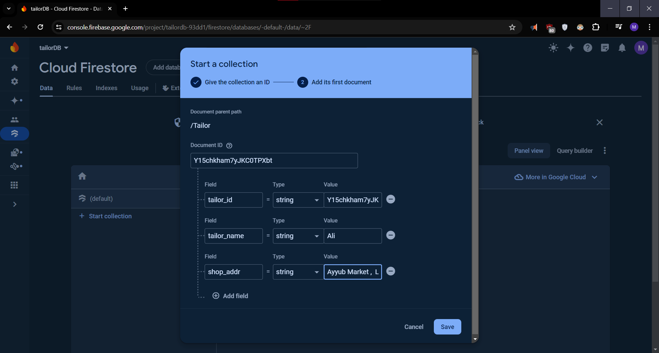 Fig 01: Creating **Tailor**’sDocument in Firebase Firestore Database

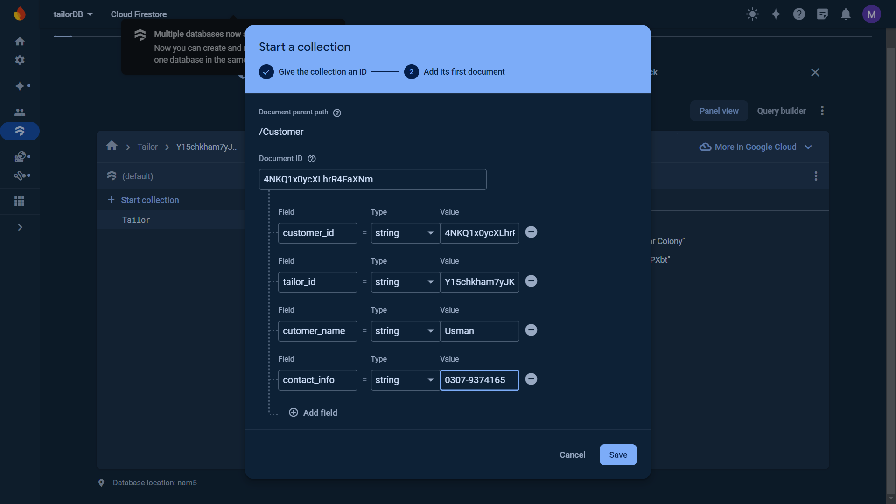 Fig 02: Creating **Customer**’sDocument

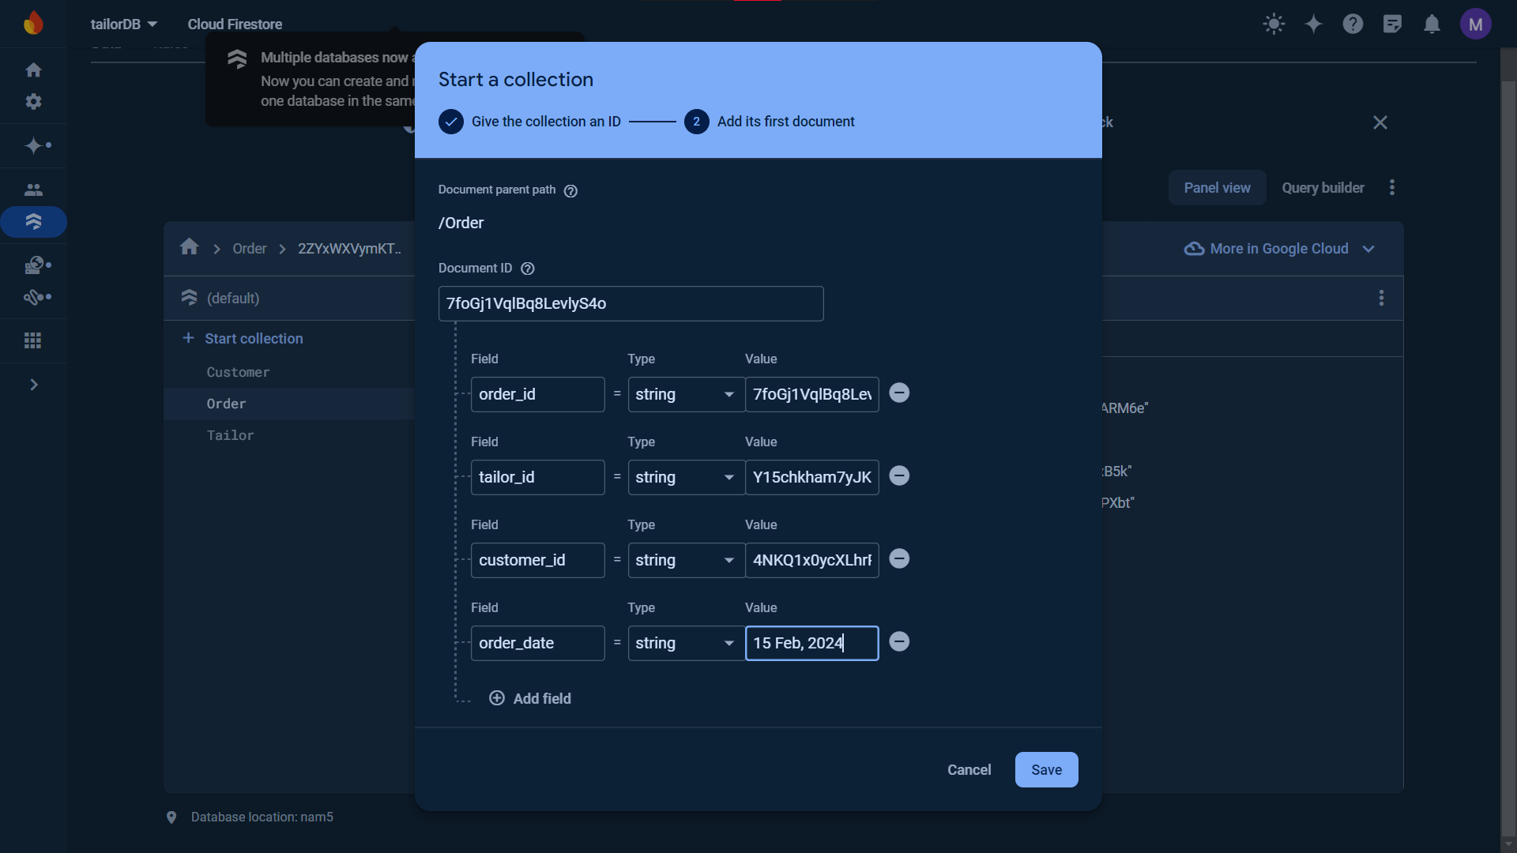Fig 03: Creating **Order**’sDocument

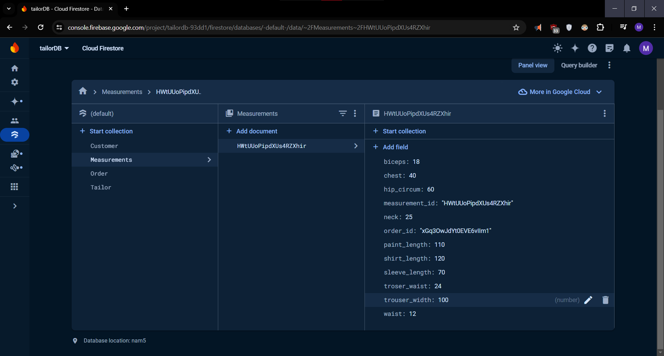

Fig 04: Creating **Measurements**’Document

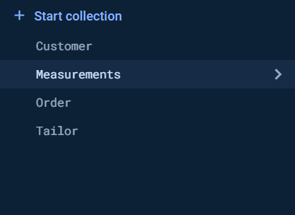

Fig 05: All the **Collections** in our Database **TailorDB**

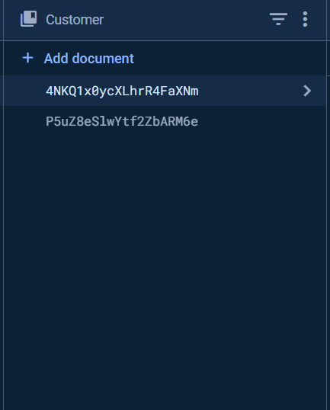

Fig 06: Our Customers will grow here

For every **customer** here a document will be created and each **customer** will have an **order** and a **measurement**.

Customer

Order

Tailor

Measurements

Fig 07: Our Collections are dependent this way on each other

Our **Order** will link our **Customer** to **Measurements** and **Tailor.**

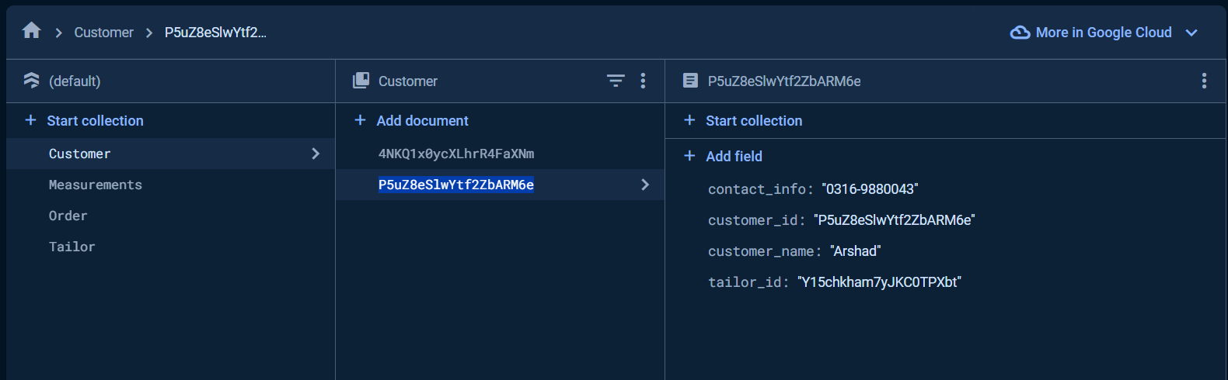Fig 08: Customer’s Fake Data

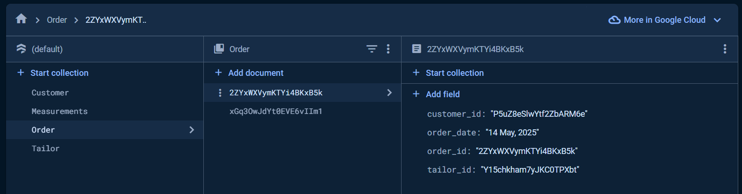Fig 09: Order’s Fake Data

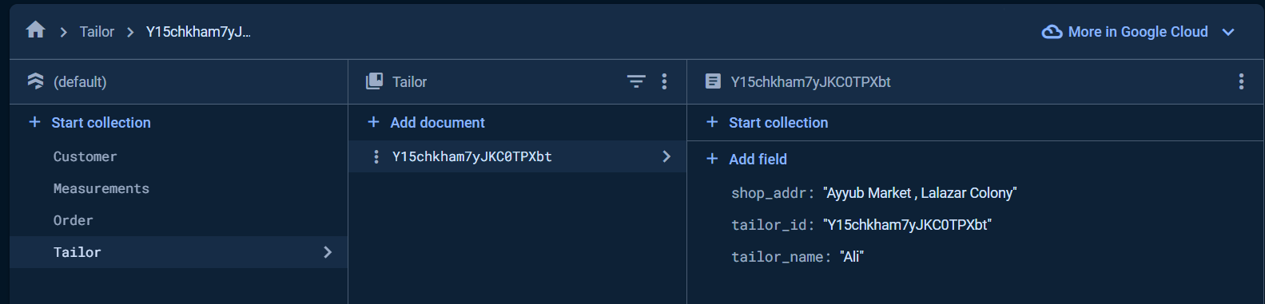Fig 10: Tailor’s Fake Data

This data was inserted manually in the database and no commands were use.

___________________________________________________________________________________